- Purpose

The purpose of this procedure is to outline the steps necessary to check and clean the basket strainer used in the Water Recovery System. It is important that this strainer be cleaned each shift to ensure smooth operation.

- Scope

This procedure applies to the water recovery basket strainer at the Manufacturing Facility. This procedure shall be performed once per shift.

- Responsibility

Lead Operator is responsible for performing this procedure once per shift.

- Safety Considerations

All Contractors/Service Personnel are expected to observe all safety rules and regulations while on Giles Chemical property.

Safety is a condition of employment. Employees are not authorized to work in an unsafe manner and are prohibited from harming the environment of the facility or community.

- Materials/Equipment

- Tools necessary for PM of Water Recovery Basket Strainer

6.0 Procedure
This Preventive check and clean procedure should be conducted only under the direct supervision of the Lead Operator of the shift who will be responsible for ensuring that the strainer is cleaned on a per shift basis.

- Shutoff the upper and lower isolation valves for the strainer to isolate the strainer from the system. Figure 1 and 2.
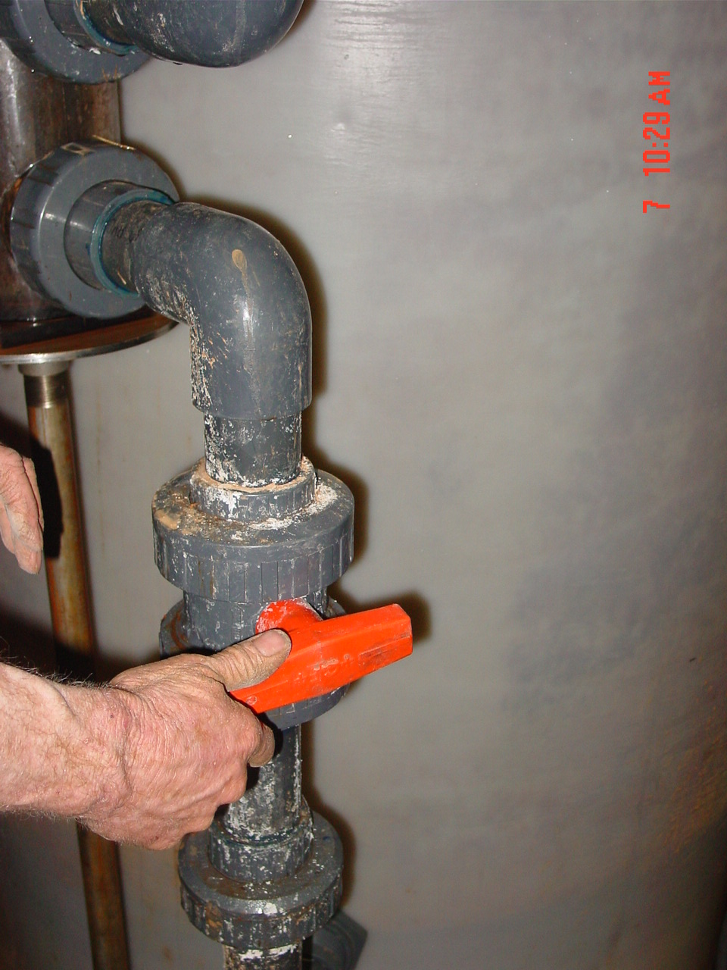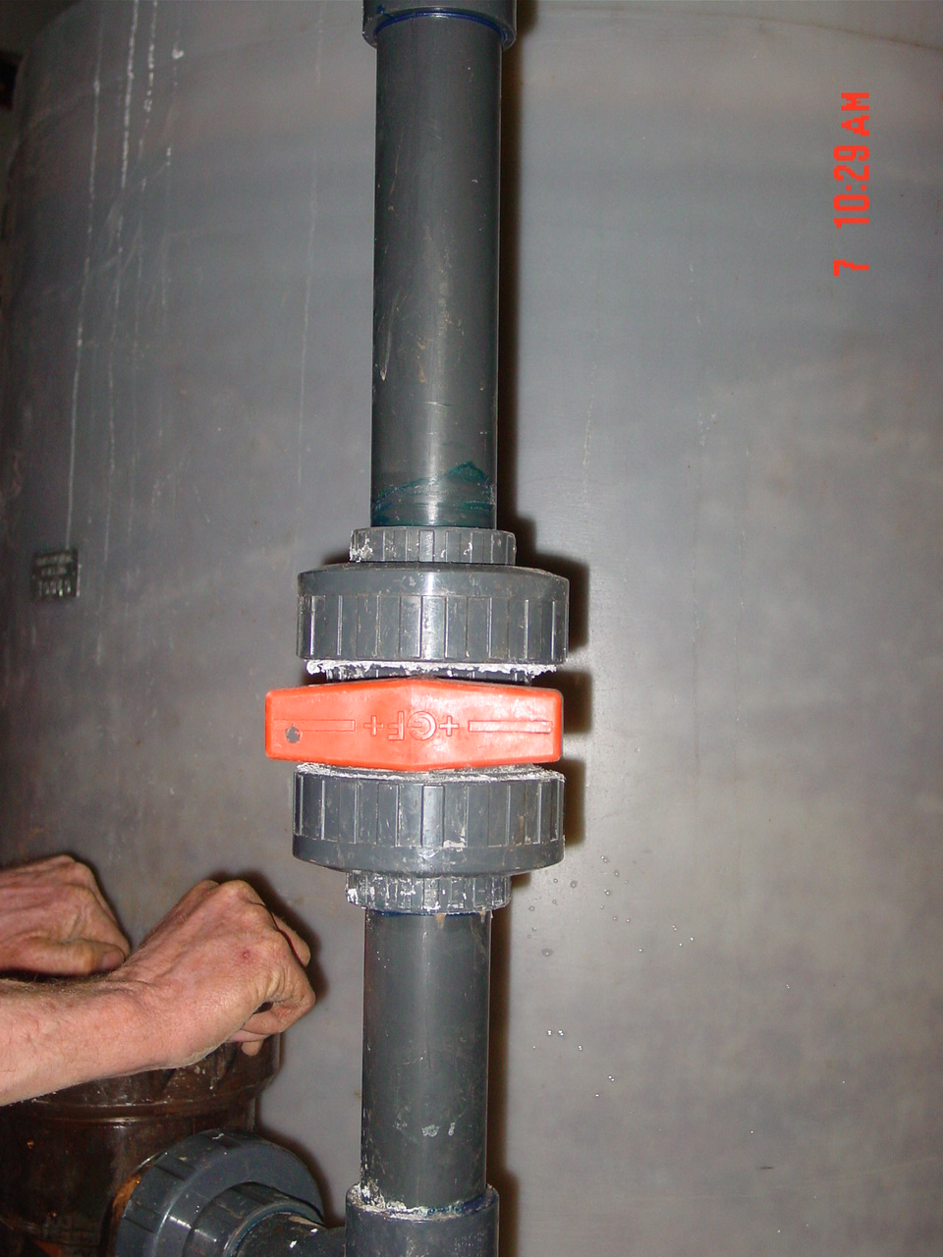
Figure 1 Figure 2
- Open the top of the strainer and remove the basket.
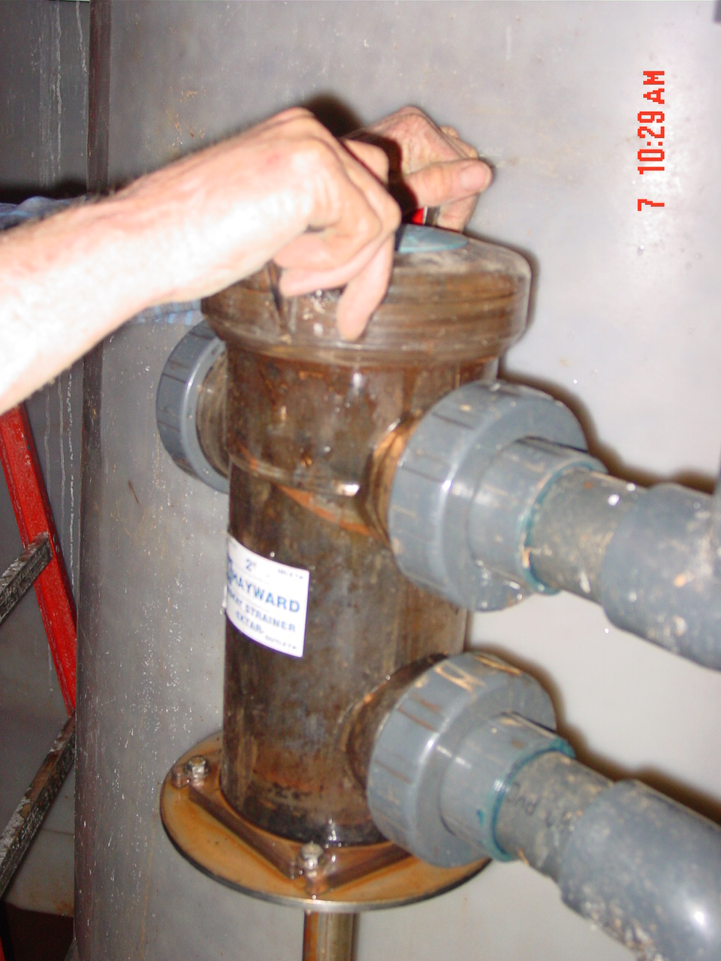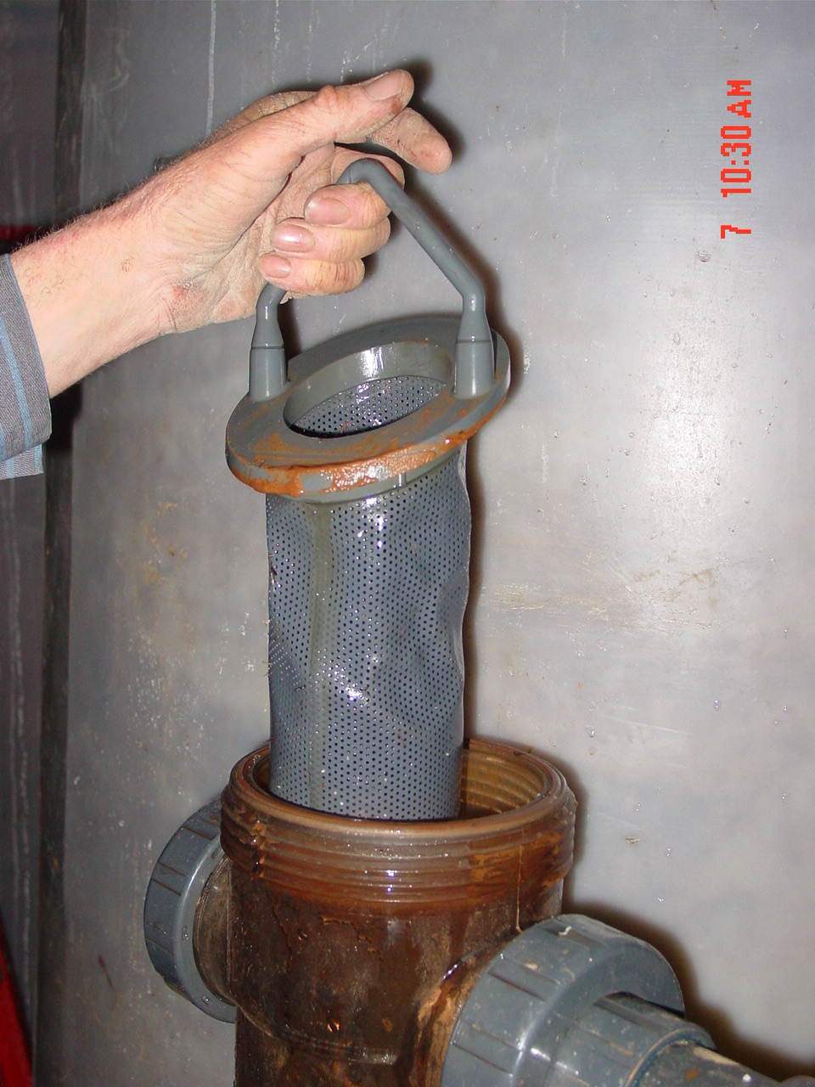

- Clean strainer (Figure 1) and place back in basket closing top securely (Figure 2).
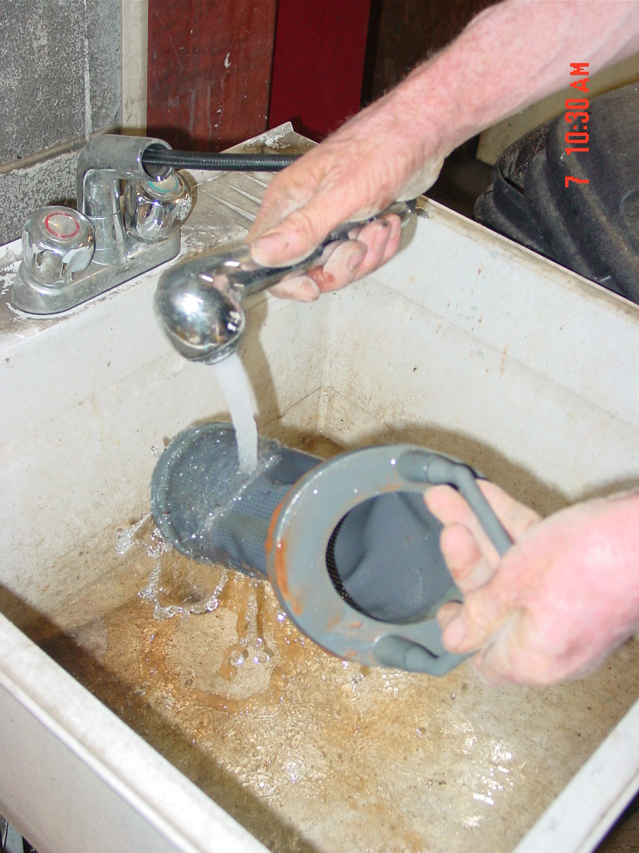
Figure 1 Figure 2
- Re-open both isolation valves and confirm system is operating properly.

- Reference Documents

N/A

- Change Information

Document review- updated format using new template and numbering system.

